Create an IAR project in HMC -E54

1. Refer the Github file below:

<https://github.com/Microchip-MPLAB-Harmony/quick_docs/blob/master/basic/create_iar_or_keil_project_using_mhc/readme.md>

**in your Harmony** repository to run: **runmhc.bat**

**then follow the step to create you IAR project.**

**2. using IAR to open your project and set the device**

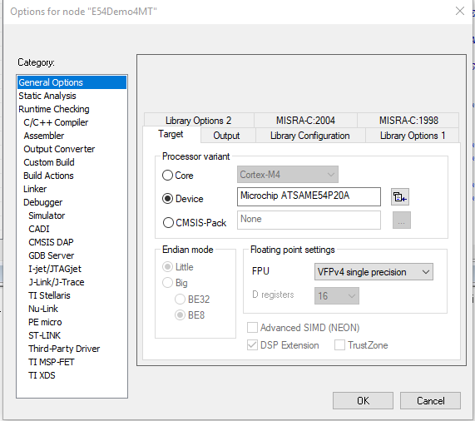

3. set directory

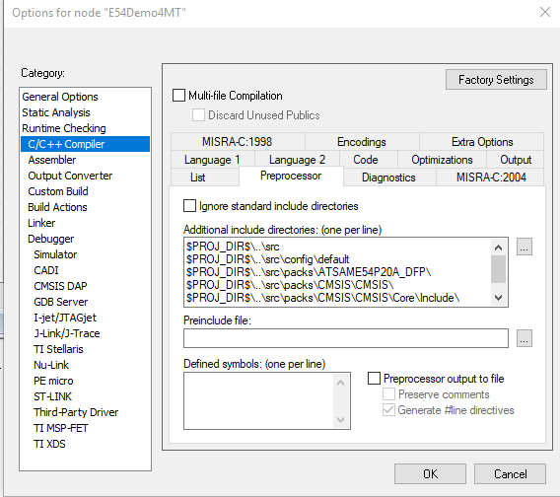

4. Select the debugger

If you use xplained Demo(edbg), it should be:

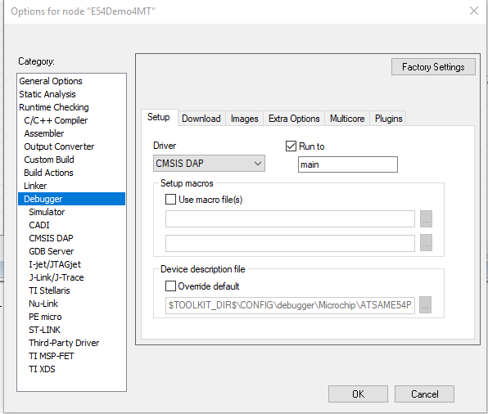

Appendix

在IAR C代码中嵌入编译时间

__DATE__;//取编译时间

__TIME__;//取编译时间

## IAR参数变量

<https://blog.csdn.net/weixin_33811539/article/details/85600349?utm_medium=distribute.pc_relevant.none-task-blog-BlogCommendFromMachineLearnPai2-2.nonecase&depth_1-utm_source=distribute.pc_relevant.none-task-blog-BlogCommendFromMachineLearnPai2-2.nonecase>

您可以为路径和参数使用参数变量，例如，当您在选项对话框中指定include路径时，或者当需要基于当前上下文的类似宏的扩展时，例如在工具的参数中。您可以使用广泛的预定义参数变量以及创建自己的参数变量，请参见配置自定义参数变量对话框。这些是预定义的参数变量:

| **Variable** | **Description** |
| --- | --- |
| $COMPILER_ARGS$ | All compiler options except for the filename that is used when compiling using the compiler. Note that this argument variable is restricted to the Arguments text box in the External Analyzer dialog box.所有编译器选项，除了使用编译器编译时使用的文件名。请注意，此参数变量仅限于“外部分析器”对话框中的“参数”文本框。 |
| $CONFIG_NAME$ | The name of the current build configuration, for example Debug or Release.所有编译器选项，除了使用编译器编译时使用的文件名。请注意，此参数变量仅限于“外部分析器”对话框中的“参数”文本框。 |
| $CUR_DIR$ | Current directory.当前目录 |
| $CUR_LINE$ | Current line当前行 |
| $DATE$ | Today’s date今天的日期 |
| $EW_DIR$ | Top directory of IAR Embedded Workbench, for example c:\Program Files\IAR Systems\Embedded Workbench N.n IAR Embedded Workbench的顶级目录，例如c：\ Program Files \ IAR Systems \ Embedded Workbench N.n |
| $EXE_DIR$ | Directory for executable output可执行输出目录 |
| $FILE_BNAME$ | Filename without extension无扩展名的文件名 |
| $FILE_BPATH$ | Full path without extension全路径无延伸 |
| $FILE_DIR$ | Directory of active file, no filename灵活文件目录，无文件名 |
| $FILE_FNAME$ | Filename of active file without path没有路径的活动文件的文件名 |
| $FILE_PATH$ | Full path of active file (in Editor, Project, or Message window)活动文件的完整路径（在编辑器，项目或消息窗口中） |
| $LIST_DIR$ | Directory for list output列表输出目录 |
| $OBJ_DIR$ | Directory for object output目标输出目录 |
| $PROJ_DIR$ | Project directory项目目录 |
| $PROJ_FNAME$ | Project filename without path没有路径的项目文件名 |
| $PROJ_PATH$ | Full path of project file项目文件的完整路径 |
| $TARGET_DIR$ | Directory of primary output file主输出文件目录 |
| $TARGET_BNAME$ | Filename without path of primary output file and without extension文件名无路径的主输出文件，无扩展名 |
| $TARGET_BPATH$ | Full path of primary output file without extension主要输出文件的完整路径，无需扩展 |
| $TARGET_FNAME$ | Filename without path of primary output file没有主输出文件路径的文件名 |
| $TARGET_PATH$ | Full path of primary output file主输出文件的完整路径 |
| $TOOLKIT_DIR$ | Directory of the active product, for example c:\Program Files\IAR Systems\Embedded Workbench N.n\arm活动产品的目录，例如c：\ Program Files \ IAR Systems \ Embedded Workbench N.n \ arm |
| $USER_NAME$ | Your host login name您的主机登录名 |
| $WS_DIR$ | The active workspace directory (only available in the IDE, not when using iarbuild.exe or cspybat.exe)活动工作区目录（仅在IDE中可用，而不是使用iarbuild.exe或cspybat.exe时） |
| $_ENVVAR_$ | The Windows environment variable ENVVAR. Any name within $_ and _$ will be expanded to that system environment variable.Windows环境变量ENVVAR。 $ _和_ $中的任何名称都将扩展到该系统环境变量。 |
| $MY_CUSTOM_VAR$ | Your own argument variable, see Configure Custom Argument Variables dialog box. Any name within $ |

|  |  |
| --- | --- |
|  | |
| Variable | Description |
| $CONFIG_NAME$ | The name of the current build configuration, for example Debug or Release. |
| $CUR_DIR$ | Current directory    //当前目录 |
| $CUR_LINE$ | Current line          //当前行 |
| $DATE$ | Today’s date |
| $EW_DIR$ | Top directory of IAR Embedded Workbench, for example c:\program files\iar systems\embedded workbench 6.n //EW的安装目录 |
| $EXE_DIR$ | Directory for executable output                //可执行文件的输出目录 |
| $FILE_BNAME$ | Filename without extension                    //无扩展名文件 |
| $FILE_BPATH$ | Full path without extension                    //无扩展名全部路径 |
| $FILE_DIR$ | Directory of active file, no filename         //当前活动文件目录,不包含文件名 |
| $FILE_FNAME$ | Filename of active file without path         //当前活动文件,不包含路径 |
| $FILE_PATH$ | Full path of active file (in Editor, Project, or Message window)  //当前活动文件的完整路径 |
| $LIST_DIR$ | Directory for list output                         //列表文件的输出路径 |
| $OBJ_DIR$ | Directory for object output                    //目标文件输出路径 |
| $PROJ_DIR$ | Project directory                                  //工程目录 |
| $PROJ_FNAME$ | Project filename without path                //工程名称  不包含路径 |
| $PROJ_PATH$ | Full path of project file                         //工程文件的完整路径 |
| $TARGET_DIR$ | Directory of primary output file             //主输出文件路径 |
| $TARGET_BNAME$ | Filename without path of primary output file and without extension     //无主输出文件目录,无扩展名的文件名 |
| $TARGET_BPATH$ | Full path of primary output file without extension      //无扩展名的主输出文件的完整路径 |
| $TARGET_FNAME$ | Filename without path of primary output file            //无路径的主输出文件名 |
| $TARGET_PATH$ | Full path of primary output file                              //主输出文件的完整路径 |
| $TOOLKIT_DIR$ | Directory of the active product, for example c:\program files\iar systems\embedded workbench 6.n\arm   //已激活的开发环境的目录 |
| $USER_NAME$ | Your host login name |
| $_ENVVAR_$ | The environment variable ENVVAR. Any name within $_ and _$ will be expanded to that system environment variable. |

在IAR中的help中输入argument variables时会找到这样的一个列表：

Argument variables

On many of the pages in the Options dialog box, you can use argument variables for paths and arguments: